
Business / Technical Brief

PEOPLESOFT TO UNIFIER –CONTRACTS
INTEGRATIONS DESIGN SPECIFICATION DOCUMENT
Prepared For: Northwestern Memorial Healthcare

  - Author: Anu Samantha
June 2025, Version 1.0
Copyright © 2025, Oracle and/or its affiliates
Confidential – Oracle Restricted
Document Control

Change Record
Date | Author | Version | Change Reference
06/24/2025 | Anu Samantha | 1.0 | Initial Draft

Reviewers
Full Name | Title
Farkas-Loewes, Monika | NM Business
VanZale, Steve | NM IT
Agrawal, Amit | NM IT
Singh, Vishnu Devanand | NM IT

Approvals:
Approver 1 | Farkas-Loewes, Monika
Approver 2 | Cloutier, Charlie

Table of Contents
1 Introduction 5
1.1 Purposes 5
1.2 Audience 5
1.3 References 5
2 Integrations Overview 6
3 Interface Design 7
3.1 I8040- PeopleSoft Contract Data to Unifier Contract Data 7
3.1.1 Properties of the Data Flow 7
3.1.2 Business Rules 8
3.1.3 Process Flow 9
3.1.4 Data Mapping 10
3.1.5 PIF Configuration 10
3.1.6 Error/Warning Handling 11
4 Assumptions 12
5 Appendix A: Acronyms 13
6 Appendix B: Issue Log 14

Table of Figures
Figure 1: Interface Details 6
Figure 2: High Level Interface Diagram 6
Figure 3: I8040 – PeopleSoft Contract Data to Unifier Contract Data 7
Figure 36: Acronyms 13
Figure 37: Issue Log 14

Introduction
Integration is the process of moving data from one data source to another on a recurring basis. The intention is to keep the target data source synchronized with relevant data from another data source. One is typically the “system-of-record”. The integrations for Northwestern Memorial Healthcare will be developed and configured using Oracle Project Integration Framework (PIF) referred as PIF henceforth on this document.

Purposes
The purpose of this document is the following:
- Document Oracle’s technical design and process flow for the interface
- As a deliverable, allow Northwestern Memorial Healthcare to approve and sign-off on the technical design.
- Document and maintain changes to the design over time.
- Provide future administrators and developers technical documentation to support the interface.

Audience
This document is intended for the following audiences:
- Technical resources supporting infrastructure.
- Application administrators and developers
- Northwestern Memorial Healthcare and Oracle Project Managers
- Solution Architects
- Business

References
This design specification refers the following information sources:
- Meetings and discussions with Northwestern Memorial Healthcare and Oracle teams.
- Field mapping identified by Northwestern Memorial Healthcare and Oracle teams.
- Future Process model
- Oracle’s Solution Design documents

Integrations Overview
This document covers the design details for transferring financial data from PeopleSoft to Primavera Unifier using PIF. PIF leverages web services to interface with PeopleSoft and Primavera Unifier.
The interfaces will be scheduled to run within PIF, and it also provides transaction log to view status of the integration jobs and email notifications for reporting transaction details and failures.
The below table details interface that will be implemented within the scope of integrations from PeopleSoft to Unifier. The term “Inbound” and “Outbound” is with the context to Primavera Unifier.

ID | Interface Name | Interface  Type | Source  System | Target  System
I8040 | I8040 - PeopleSoft Contract Data to Unifier Contract Data | Inbound | PeopleSoft | Unifier
Figure 1: Interface Details

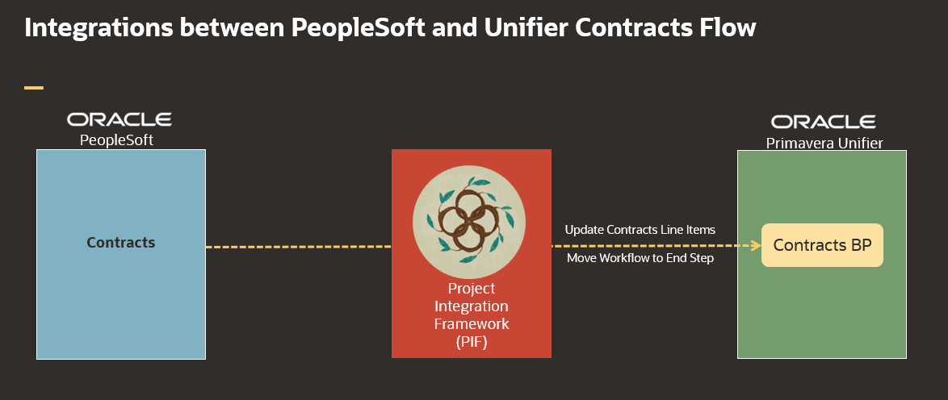
Figure 2: High Level Interface Diagram

Interface Design

I8040- PeopleSoft Contract Data to Unifier Contract Data
This interface is used to retrieve the contract Line items information from PeopleSoft to update Contract BP Line-Item records in Unifier. Additionally, this integration will move the contract records workflow to End step after updating Line Items.

Properties of the Data Flow
Interface ID | I8040
Interface Name | I8040 - PeopleSoft Contract Data to Unifier Contract Data
Source System Name | PeopleSoft
Source System Object Name(s) | TBD
Target System Name | Unifier
Target System Object Name(s) | Contracts BP
Interface Type | Inbound
Interface Frequency | Nightly- Once
Approximate # of Rows | 40 Contracts Per Month
Interface Mechanism | Unifier –Contracts BP  PeopleSoft – Views
Table Name Prefix | I8040
Figure 3: I8040 – PeopleSoft Contract Data to Unifier Contract Data

Business Rules
Rule # | Rule Name | Rule Description
R-01 | Selection Criteria | Only Pending Purchase Order creation status Contracts will be sent from PeopleSoft to Unifier
R-02 | Source Code | POs will be sent with lines under Construction (Source Code 2000) for Contracts BP
R-03 | Project Level only | Get all Contracts by Project ID, to be created in Unifier at Project Level only
R-04 | Workflow End Step | Unifier Project Number and Unifier Contract Record Number will be unique combination to update contracts and move workflow End Step
R-05 | Vendor | The PeopleSoft Vendor ID must exist in a Unifier vendor record to be selected as the Vendor for a given Contract record

Process Flow
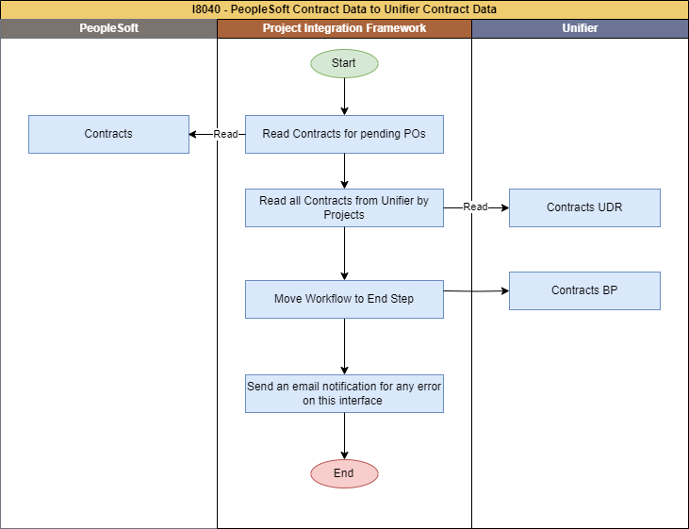
Figure 3: I8040 - PeopleSoft Contract Data to Unifier Contract Data

- Truncate PIF staging tables upon integration start.
- PIF to read contract data from PeopleSoft based on creation date/Update Date, Having Source Code 2000(Construction) ; store into PIF staging table.
- PIF to read all existing contract data from Unifier via user defined report.
- PIF to move the Unifier contract workflow to End Step .
- Integration Last update field will be updated as SysDate – only updated by PIF Integration User (configured in Unifier Integration users)
- Populate Unifier PIF Integration status and Integration step field only in case of failures.
- Generate email error notifications if there are any errors while creating/updating Contracts data in Unifier.

Data Mapping
The below is the SharePoint link for data mapping for this interface.
Oracle-NM-PeopleSoft-Unifier-Contracts-Integration-Mapping.xlsx

PIF Configuration
Interface Name: I8040 - PeopleSoft Contract Data to Unifier Contract Data

To be filled/corrected after completion of interface development.

Step No/ Intent | Step information | Business Rules / Comments
Step #: 10  Step Name: Truncate PIF tables | Service Name: SQL Service  SQL Type: DELETE  Table Name:  I8040_PSFT_CONTRACTS,  I8040_PSFT_CONTRACTS_ROWS,  I8040_UNI_CONTRACTS | Truncate all PIF tables, stage tables
Step #: 20  Step Name: Get Contracts from PeopleSoft based on Create/Update date | Service Name: PeopleSoft View  SQL Type: SELECT  Table Name: I8040_PSFT_CONTRACTS | Get PeopleSoft contracts that have been created in the last 24 hours and have Source Code 2000 (Construction)
Step #: 30  Step Name: Skip if no data in PeopleSoft | Service Name: GoToService  Is Conditional: True  Go To Step Sequence: End Process (-1)  Table Name: I8040_PSFT_CONTRACTS_ROWS | Check if there are any contracts to process or not. If not Skip all the interface steps and move to end step.
Step #: 40  Step Name: Get Contracts from Unifier | Service Name: UnifierRESTV2Service  Object Name: User Defined Report  Method Name: Get UDR  UDR Name: I8040_Contract  UDR Level: Project Shell  Table Name: I8040_UNI_CONTRACTS | Get existing contracts from Unifier using UDR.
Step #: 50  Step Name: Check Contract Exists in Unifier | Service Name: SQL Service  SQL Type: SELECT  Table Name: I8040_PSFT_CONTRACTS_ROWS | Validate contracts which already exist in Unifier
Step #: 60  Step Name: Update the records to process | Service Name: SQL Service  SQL Type: SELECT  Table Name: I8040_PSFT_CONTRACTS_ROWS | Loop to process one record at a time.
Step #: 70  Step Name: Move contract workflow to End Step | Service Name: UnifierRESTV2Service  Object Name: Business Process  Method Name: Update BP Record  Business Process Name: Contract  Table Name: I8040_PSFT_CONTRACTS_ROWS | Move all updated contracts to End Step
Step #: 80  Step Name: Go to update step | Service Name: GoToService  Is Conditional: True  Go To Step Sequence: Update the records to process  Table Name: I8040_PSFT_CONTRACTS_ROWS | Move to the update step for processing the next record.
Step #: 90  Step Name: End Process, Skip to run "Notify Failures" when there are no failed records | Service Name: GoToService  Is Conditional: True  Go To Step Sequence: End Process (-1)  Table Name: I8040_PSFT_CONTRACTS_ROWS | Check if there are any failed contracts or not. If not Skip all the interface steps and move to end step.
Step #: 100  Step Name: Notify contract failures | Service Name: Email Service  Conditional Criteria: Attachment Has Records  Attachment File Name: Contract failed records.  Table Name: I8040_PSFT_CONTRACTS_ROWS | Send an attachment detailing all records which have failed to update.

Error/Warning Handling
Error # | Rule Name | Rule Description
E-01 | Contract Updates failed | Email will be sent to admin for any failure

Assumptions
- All drop down field value should be match between Unifier and PeopleSoft application.
- The data mapping sheet is designed for the flow of data from one system to another, and if a field is not added, there will be no data flow.
- PIF jobs are scheduled daily to run automatically, and they can also be run manually on demand by the administrator user.
- Contracts will be created manually in Unifier and will be manually entered to Rec-loader to load data into PeopleSoft.

Appendix A: Acronyms
Acronyms | Description
IB | Inbound
PIF | Project Integration Framework
OB | Outbound
WS | Web Services
RS | REST Services
UDR | User Defined Report
Figure 36: Acronyms

Appendix B: Issue Log
This Issue Log captures design changes made after sign-off of the use case requirements document.

Issue # | Description | Status | Date Open | Date Closed | Resolution | Comments
Figure 37: Issue Log

